1. Introduction to Data Pre-processing
- In any data analytics project, data is collected from multiple sources such as databases, web applications, sensors, or surveys.
- However, this raw data is rarely perfect — it may contain missing values, duplicate records, inconsistent entries, and noise.
- Therefore, before applying any analytics or machine learning models, the data must be cleaned and prepared.
Definition: Data Pre-processing is the technique of transforming raw data into a clean, usable format for analysis.
Importance:
- Ensures accuracy and reliability of results
- Improves model performance
- Reduces bias and inconsistencies
- Saves time in later stages of analysis
Learning Objectives:
- Understanding the definition and characteristics of outliers in data
- Recognizing why outliers occur and their potential sources (e.g., variability, experimental errors)
- Grasping the impact of outliers on statistical measures (mean, median, mode) and model performance

What are Outliers?
We all have heard of the idiom ‘odd one out which means something unusual in comparison to the others in a group. Similarly, an Outlier is an observation in a given dataset that lies far from the rest of the observations. That means an outlier treatment is vastly larger or smaller than the remaining values in the set.

Why Do they Occur?
An outlier may occur due to the variability in the data, or due to experimental error/human error.
They may indicate an experimental error or heavy skewness in the data(heavy-tailed distribution).
What Do They Affect?
In statistics, we have three measures of central tendency namely Mean, Median, and Mode. They help us describe the data.
- Mean is the accurate measure to describe the data when we do not have any outliers present.
- Median is used if there is an outlier in the dataset.
- Mode is used if there is an outlier AND about ½ or more of the data is the same.
Mean’ is the only measure of central tendency that is affected by the outlier treatment which in turn impacts Standard deviation.
Example
Consider a small dataset, sample= [15, 101, 18, 7, 13, 16, 11, 21, 5, 15, 10, 9]. By looking at it, one can quickly say ‘101’ is an outlier that is much larger than the other values.
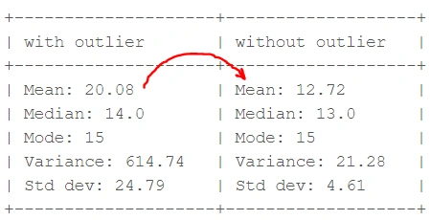
From the above calculations, we can clearly say the Mean is more affected than the Median.

Detecting Outliers
If our dataset is small, we can detect the outlier by just looking at the dataset. But what if we have a huge dataset, how do we identify the outliers then? We need to use visualization and mathematical techniques.
Below are some of the techniques of detecting outliers
- Boxplots
- Z-score
- Inter Quantile Range(IQR)

Boxplots

A boxplot displays data spread and identifies outliers using quartiles (Q1, Median, Q3). It helps detect variability and outliers.
Example: Monthly sales for regions show median sales around ₹60,000, with North region having higher variability and outliers in the South.
Definition
A Boxplot (also called a Box-and-Whisker Plot) is a graphical representation of the distribution of data based on five key summary statistics:
- Minimum (Min)
- First Quartile (Q1) – 25th percentile
- Median (Q2) – 50th percentile
- Third Quartile (Q3) – 75th percentile
- Maximum (Max)
It visually displays the spread, central tendency, and presence of outliers in a dataset.
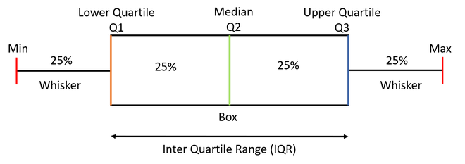

Purpose of a Boxplot
Boxplots help to:
- Identify the spread (variability) of data.
- Detect outliers (unusual values far from the rest).
- Compare distributions between multiple groups.
- Show symmetry or skewness in data.

Components of a Boxplot
Component | Meaning
Box | Represents the Interquartile Range (IQR) = Q3 - Q1 (middle 50% of data).
Median Line (inside box) | Indicates the central value of the dataset.
Whiskers | Extend to the minimum and maximum values within 1.5 × IQR.
Outliers | Points beyond whiskers, shown as dots or asterisks.

How to create a box plots?
Let us take a sample data to understand how to create a box plot.
Here are the runs scored by a cricket team in a league of 12 matches - 100, 120, 110, 150, 110, 140, 130, 170, 120, 220, 140, 110.
To draw a box plot for the given data first we need to arrange the data in ascending order and then find the minimum, first quartile, median, third quartile and the maximum.
Ascending Order
100, 110, 110, 110, 120, 120, 130, 140, 140, 150, 170, 220

Median (Q2) = (120+130)/2 = 125; Since there were even values

To find the First Quartile we take the first six values and find their median.
Q1 = (110+110)/2 = 110
For the Third Quartile, we take the next six and find their median.
Q3 = (140+150)/2 = 145
Note: If the total number of values is odd then we exclude the Median while calculating Q1 and Q3. Here since there were two central values we included them.
Now, we need to calculate the Inter Quartile Range.
IQR = Q3-Q1 = 145-110 = 35
We can now calculate the Upper and Lower Limits to find the minimum and maximum values and also the outliers if any.
Lower Limit = Q1-1.5*IQR = 110-1.5*35 = 57.5
Upper Limit = Q3+1.5*IQR = 145+1.5*35 = 197.5

So, the minimum and maximum between the range [57.5,197.5] for our given data are -
Minimum = 100
Maximum = 170

The outliers which are outside this range are -
Outliers = 220
Now we have all the information, so we can draw the box plot which is as below-
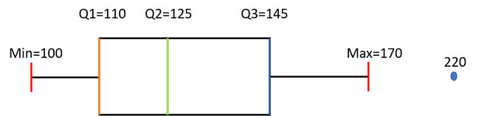

Real-Time Example: Monthly Sales Data:
A company tracks monthly sales (in ₹) for different regions.
Region | Sales (₹)
North | 55,000, 60,000, 65,000, 80,000
South | 40,000, 42,000, 85,000
East | 50,000, 55,000, 58,000, 60,000
West | 45,000, 47,000, 48,000, 50,000

Boxplot Visualization (Conceptually)
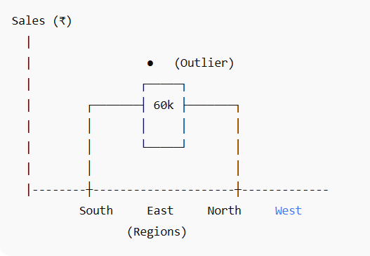

Interpretation:
- The median sales for most regions are around ₹60,000.
- North region has a wider box (higher IQR), meaning more variability in sales.
- South region shows an outlier (~₹85,000), indicating an unusually high sales month.
- West region has the lowest variability, showing consistent performance.

Real-World Applications of Boxplots
Domain | Use of Boxplot
Business & Sales | Compare sales performance across regions or months.
Education | Compare exam score distributions across classes or subjects.
Healthcare | Analyze patient recovery times across treatments.
Finance | Study income or expense distributions across departments.
Manufacturing | Monitor product quality or defect variation.

Python Code:
import matplotlib.pyplot as plt

sample= [15, 101, 18, 7, 13, 16, 11, 21, 5, 15, 10, 9]
plt.boxplot(sample, vert=False)
plt.title("Detecting outliers using Boxplot")
plt.xlabel('Sample')
plt.show()

Python Code 02:
outliers = []
def detect_outliers_iqr(data):
data = sorted(data)
q1 = np.percentile(data, 25)
q3 = np.percentile(data, 75)
# print(q1, q3)
IQR = q3-q1
lwr_bound = q1-(1.5*IQR)
upr_bound = q3+(1.5*IQR)
# print(lwr_bound, upr_bound)
for i in data:
if (i<lwr_bound or i>upr_bound):
outliers.append(i)
return outliers# Driver code
sample_outliers = detect_outliers_iqr(sample)
print("Outliers from IQR method: ", sample_outliers)

Standardization (Z-score Scaling)
Standardization transforms data to have a mean of 0 and a standard deviation of 1. It centers data around the mean, useful for algorithms that assume normally distributed data.
• Formula: Z = (X - μ) / σ
Real-Time Example: A university standardizes exam marks to compare performance across different subjects.

Criteria: any data point whose Z-score falls out of 3rd standard deviation is an outlier treatment.
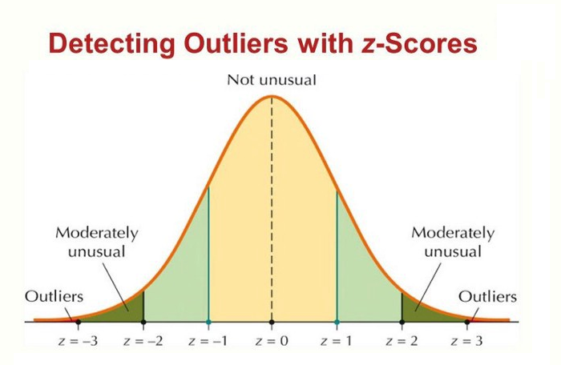
Steps
- loop through all the data points and compute the Z-score using the formula:
(Xi-mean)/std.
- define a threshold value of 3 and mark the datapoints whose absolute value of Z-score is greater than the threshold as outliers.

Python Code
import numpy as np
outliers = []
def detect_outliers_zscore(data):
thres = 3
mean = np.mean(data)
std = np.std(data)
# print(mean, std)
for i in data:
z_score = (i-mean)/std
if (np.abs(z_score) > thres):
outliers.append(i)
return outliers# Driver code
sample_outliers = detect_outliers_zscore(sample)
print("Outliers from Z-scores method: ", sample_outliers)

How to Handle Outliers?
Till now we learned about detecting the outliers handling. The main question is how to deal with outliers?
Below are some of the methods of treating the outliers:
Step 1: Trimming/Remove the outliers
In this technique, we remove the outliers from the dataset. Although it is not a good practice to follow.
Python code to delete the outlier treatment and copy the rest of the elements to another array.

# Trimming for i in sample_outliers: a = np.delete(sample, np.where(sample==i)) print(a) # print(len(sample), len(a))

Step 2: Quantile Based Flooring and Capping
In this technique, the outlier is capped at a certain value above the 90th percentile value or floored at a factor below the 10th percentile value.
Python code to delete the outlier and copy the rest of the elements to another array.
# Computing 10th, 90th percentiles and replacing the outlier treatment in python
tenth_percentile = np.percentile(sample, 10)
ninetieth_percentile = np.percentile(sample, 90)
# print(tenth_percentile, ninetieth_percentile)b =
np.where(sample<tenth_percentile, tenth_percentile, sample)
b = np.where(b>ninetieth_percentile, ninetieth_percentile, b)
# print("Sample:", sample)
print("New array:",b)

The above code outputs: New array: [15, 20.7, 18, 7.2, 13, 16, 11, 20.7, 7.2, 15, 10, 9]
The data points that are lesser than the 10th percentile are replaced with the 10th percentile value and the data points that are greater than the 90th percentile are replaced with 90th percentile value.

Step 3: Mean/Median Imputation
As the mean value is highly influenced by the outlier treatment, it is advised to replace the outliers with the median value.
median = np.median(sample)# Replace with median for i in sample_outliers: c = np.where(sample==i, 14, sample) print("Sample: ", sample) print("New array: ",c) # print(x.dtype)

Visualizing the Data after Treating the Outlier

plt.boxplot(c, vert=False)
plt.title("Boxplot of the sample after treating the outliers")
plt.xlabel("Sample")
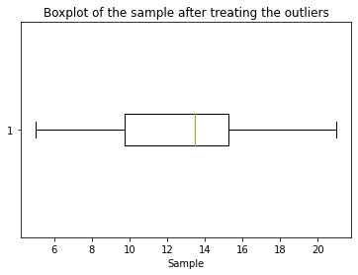

Key Takeaways:
- Learning techniques to detect outliers: boxplots, Z-score method, interquartile range (IQR) method
- Strategies to handle outliers: trimming/removing, quantile-based flooring and capping, mean/median imputation
- Visualizing and evaluating the data after treating outliers for improved analysis and decision-making
Encoding Categorical Variables
Categorical variables must be converted into numerical format for analysis and modeling. Encoding helps represent text-based data as numbers.
Type | Description
Label Encoding | Assigns unique integers to each category (e.g., Male=0, Female=1).
One-Hot Encoding | Creates binary columns for each category (e.g., Delhi=[1,0,0], Mumbai=[0,1,0]).
Ordinal Encoding | Encodes categories with natural order (Low=1, Medium=2, High=3).

Example:Real-Time Scenario: In a telecom company, regions (‘North’, ‘South’, ‘East’, ‘West’) are encoded numerically before feeding data into a churn prediction model.

